

**The Lulu eGames Verizon Student Innovator Challenge**

**Traces Executive Summary & Design Rendering**

Idea:

The end goal of this application is to allow a normal person to click on a map location and be provided information about individuals who have previously visited that location (and to pivot from this search to related information). This is accomplished by displaying publically available, location-aware data points accumulated through the use of APIs from various social networks. This concept is loosely based on [Keith Lee's OSINT Stalker](https://github.com/milo2012/osintstalker) tool, but is intended to be used by normal people.

By witnessing the amount of information that others have unknowingly shared with perfect strangers, this app would serve as an educational tool to help users make safer decisions about what types of information to post online (i.e. it is a bad idea to talk about going on vacation before you do so since it tells people that you are not home).

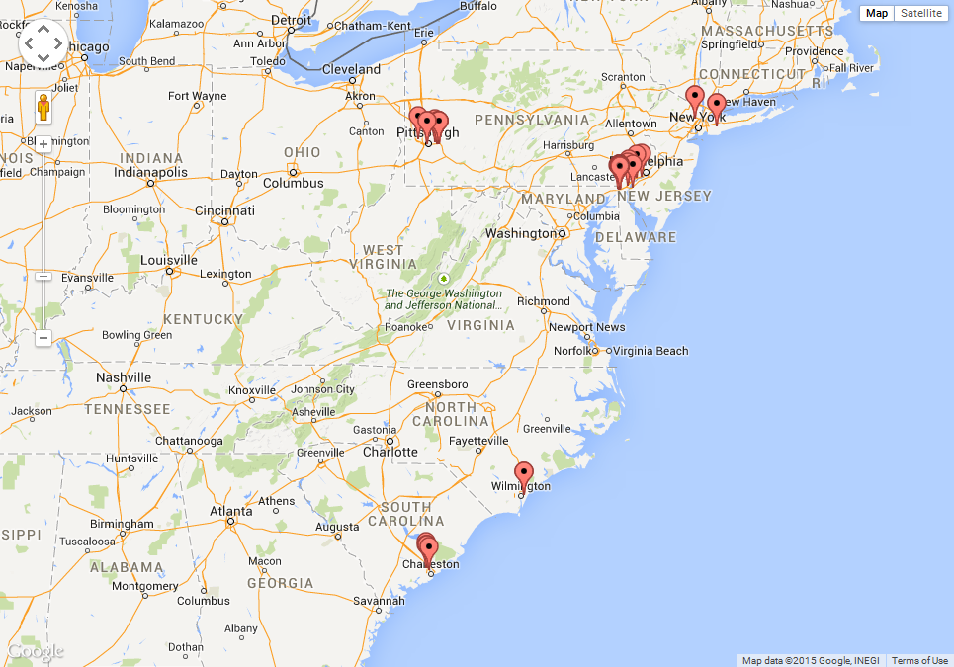

The design will be separated into two parts: a backend REST API and a frontend Android application. The use of a backend API will allow for better performance since this backend will fetch data from multiple APIs and return a minimized result to the [Android] client. Also, we don’t want to store API keys directly in the client for security reasons. In the future, it will be possible to write a web app to duplicate the functionality of the Android app.

REST API:

1. JSON
   1. Allows for easy creation of different front ends
2. Runs on Google App Engine
   1. Excellent uptime
   2. Distributed worldwide
   3. Speed up queries since App Engine will do all the heavy lifting
3. Written in Go
   1. Excellent concurrency primitives
4. Start with Twitter API
   1. Search by geo coordinate
   2. Search by address
   3. Search by Twitter screen name
5. Add other APIs as time permits

Android Frontend:

1. Consume JSON API
2. Visualize data on Google Maps
   1. Largely open-ended
3. App Icon  
   
4. UI Mockup  
   